**LINUX**

1. **The largest number entered by the user**

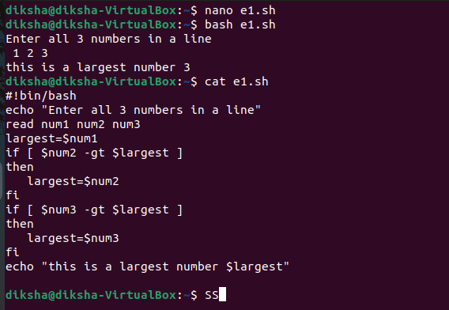

1. **Write a shell script to display a menu like**

**1.Date 2. Cal 3. ls 4.pwd 5. Exit**

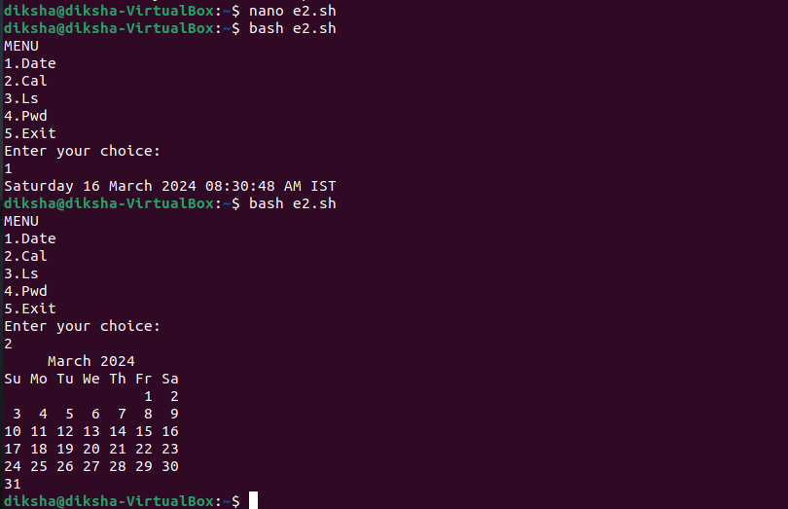

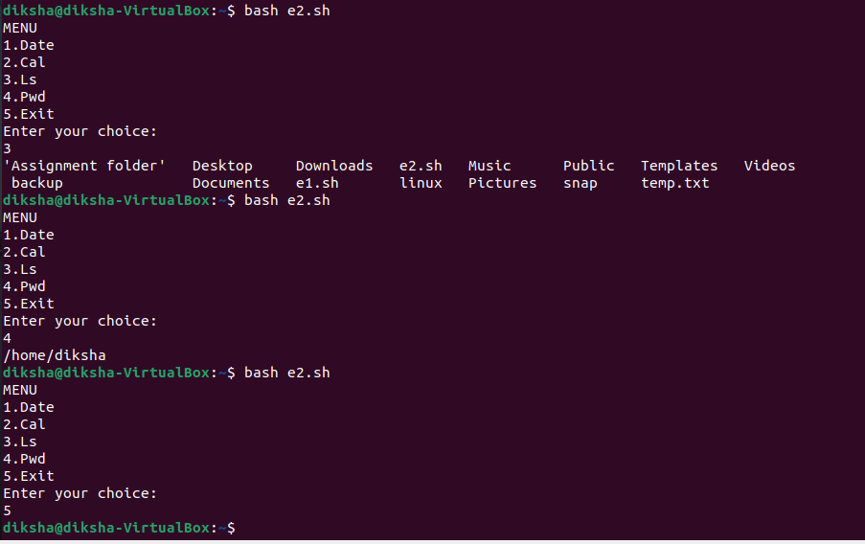

3. Linux directory and file management script

1. Create a new directory with a specific name

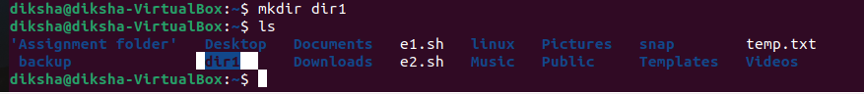

1. Rename an existing directory with a new name
2. 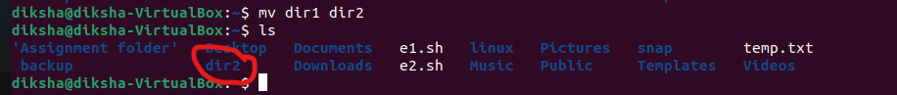
3. Move an existing directory to a new location

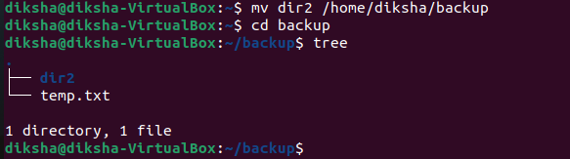

1. Delete an existing directory.

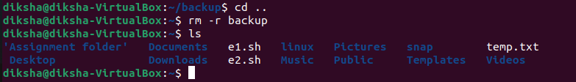

1. Create a new file in the specified directory with a specified name and give read-write permission to a user group.

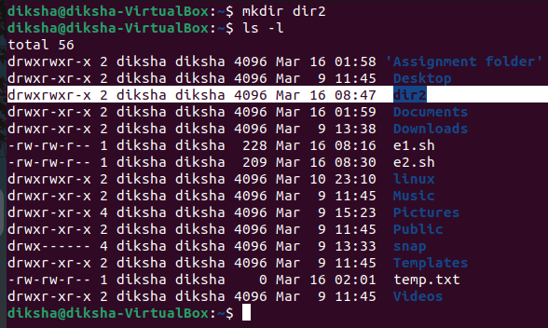

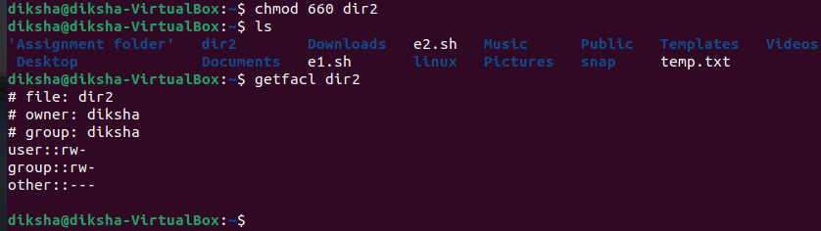

CLOUD

CREATING A LINUX EC2

1.SELECT EC2

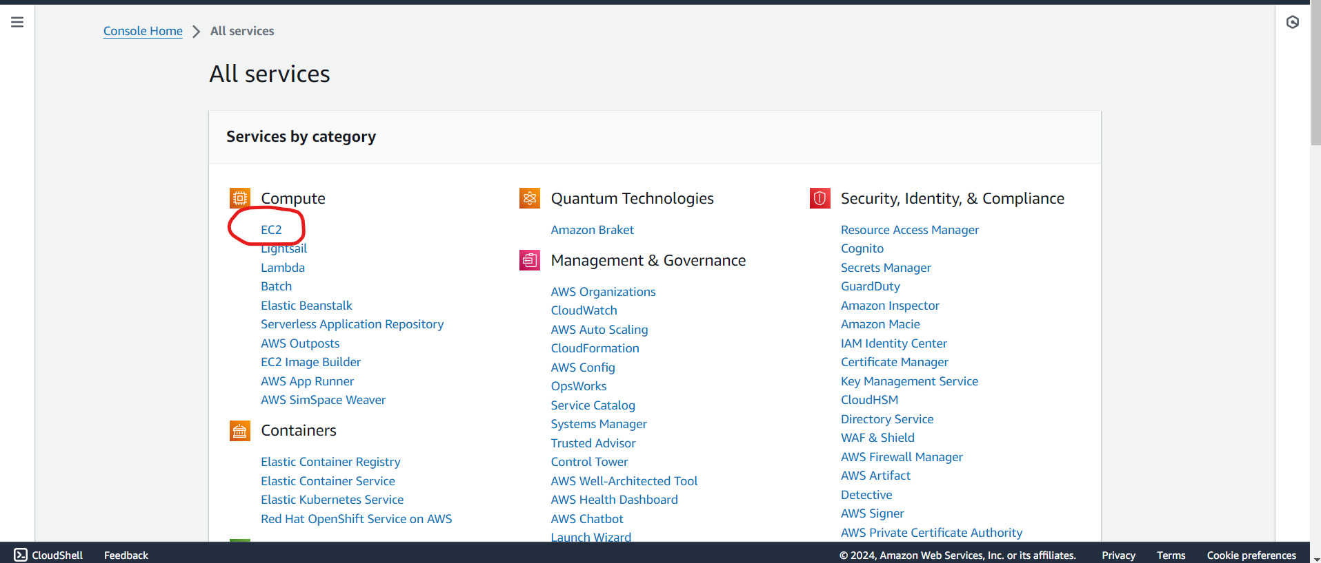

2. CLICK ON LAUNCH INSTANCE

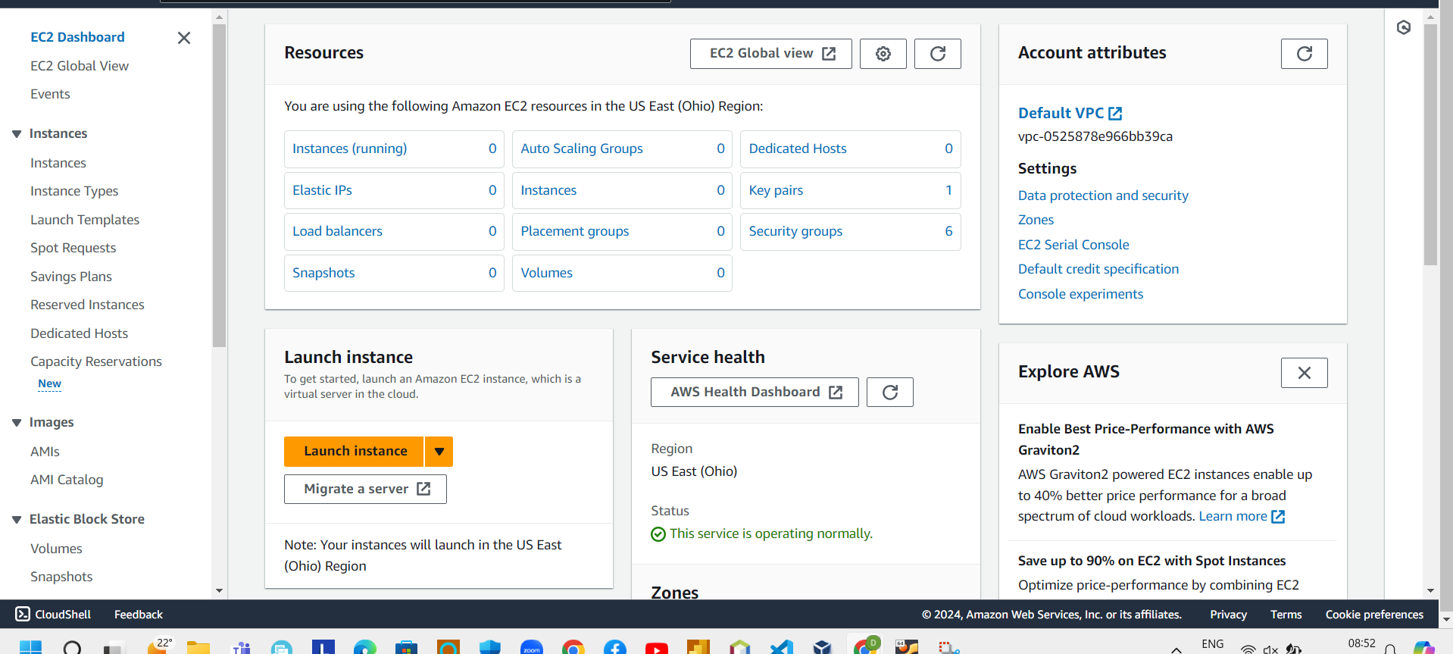

3. GIVE A NAME TO A INSTANCE

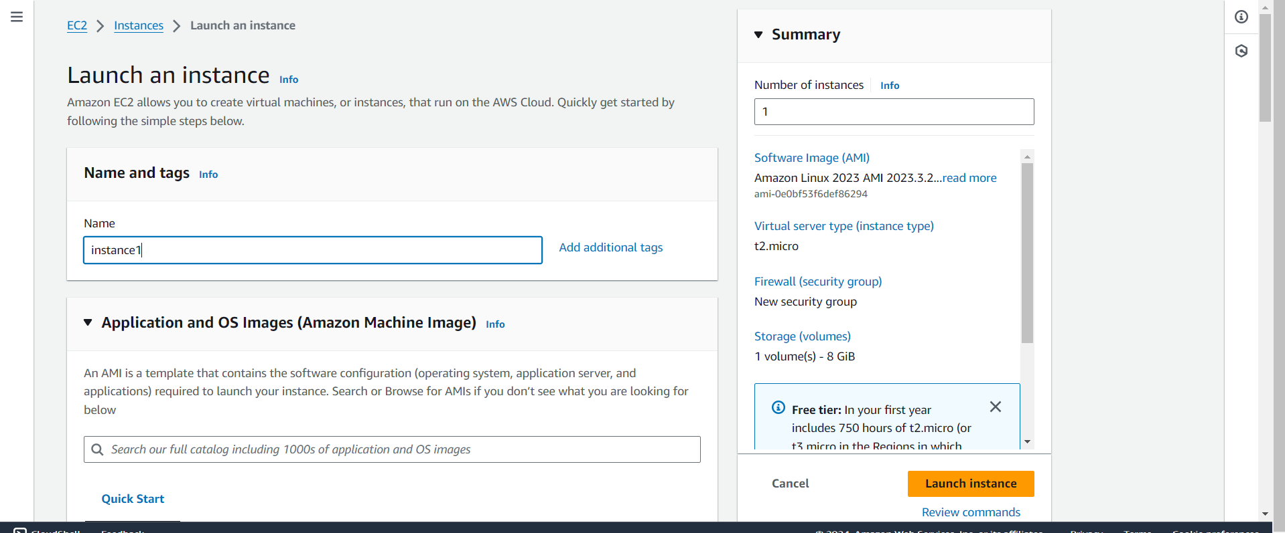

4. CRATE A KEY PAIR

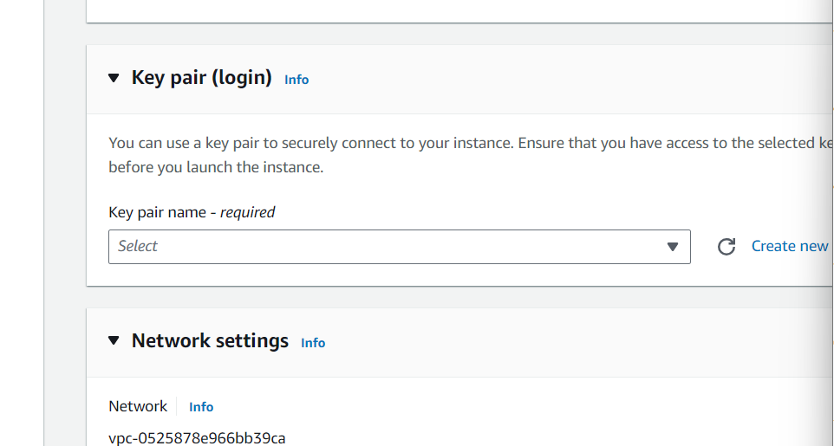

5. CLICK ON CREATE A NEW KEY PAIR

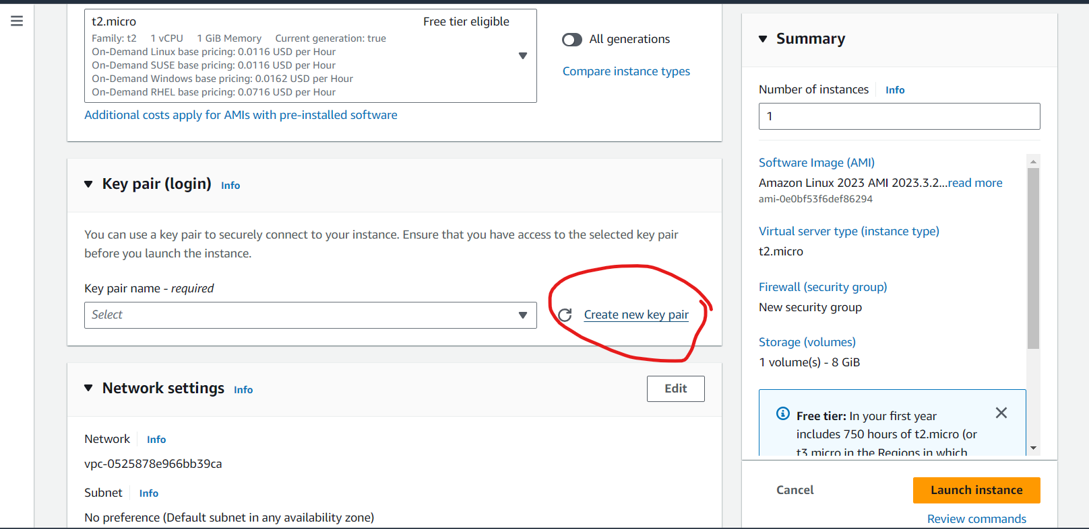

6. Give a name to a key pair

select the.ppk file a

Click on Create Key pair

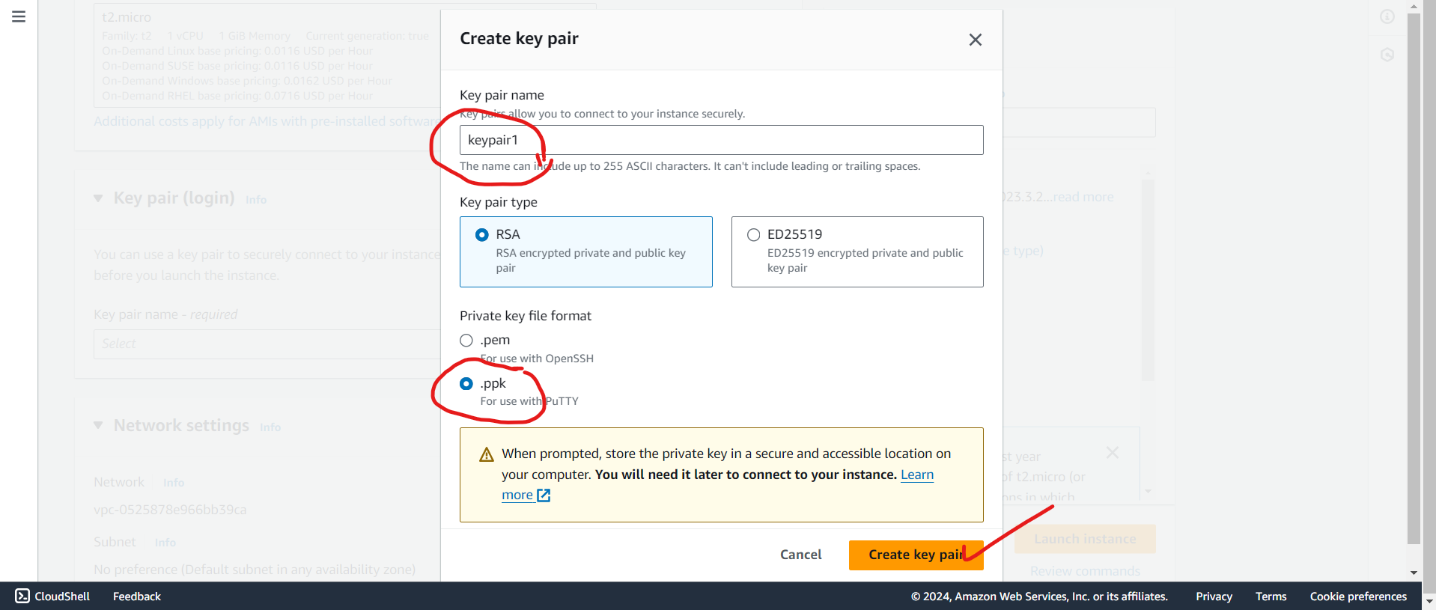

1. Tick both checkboxes and allow HTTP traffic from the internet

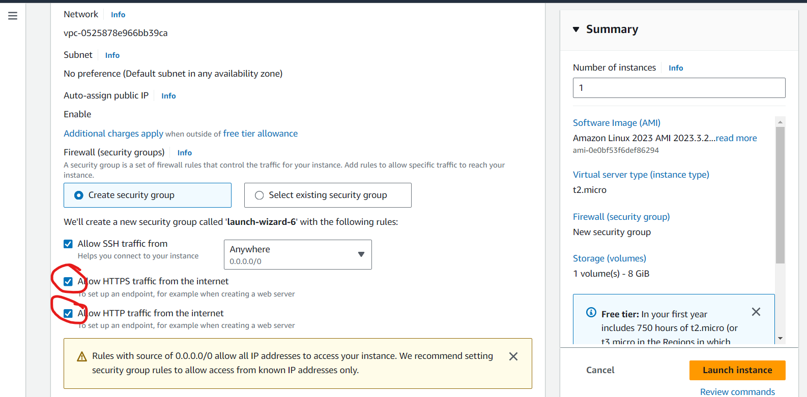

8.click on launch instance

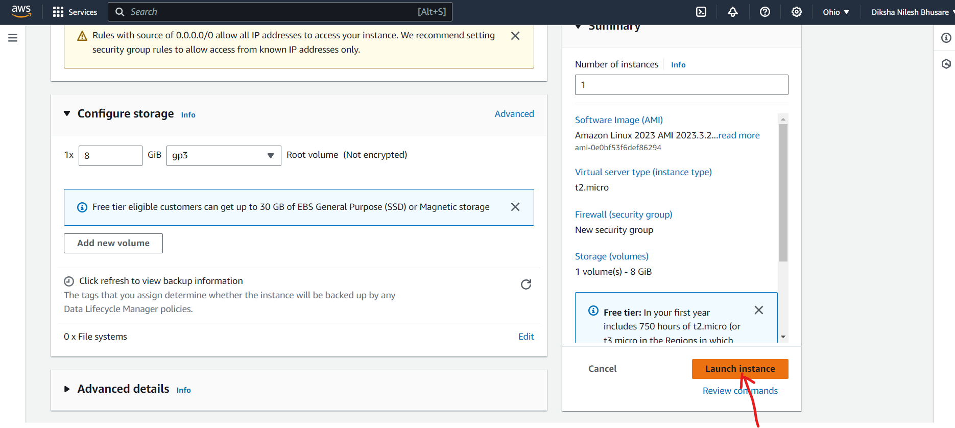

9. launching the instance

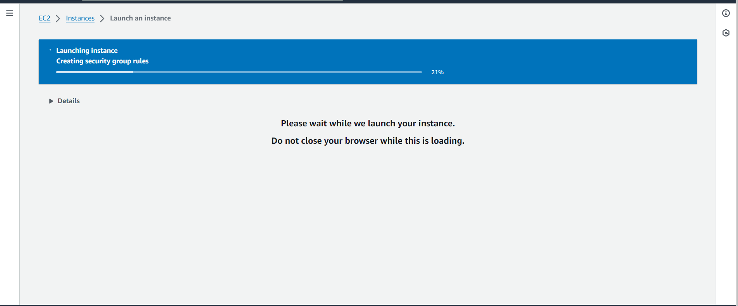

10. We need to click on that number link

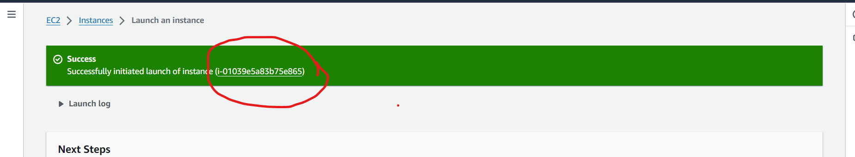

11. Our instance is created

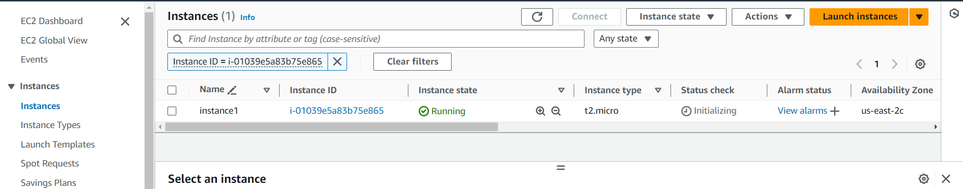

12. Copy the instance ipv4 and paste into the putty

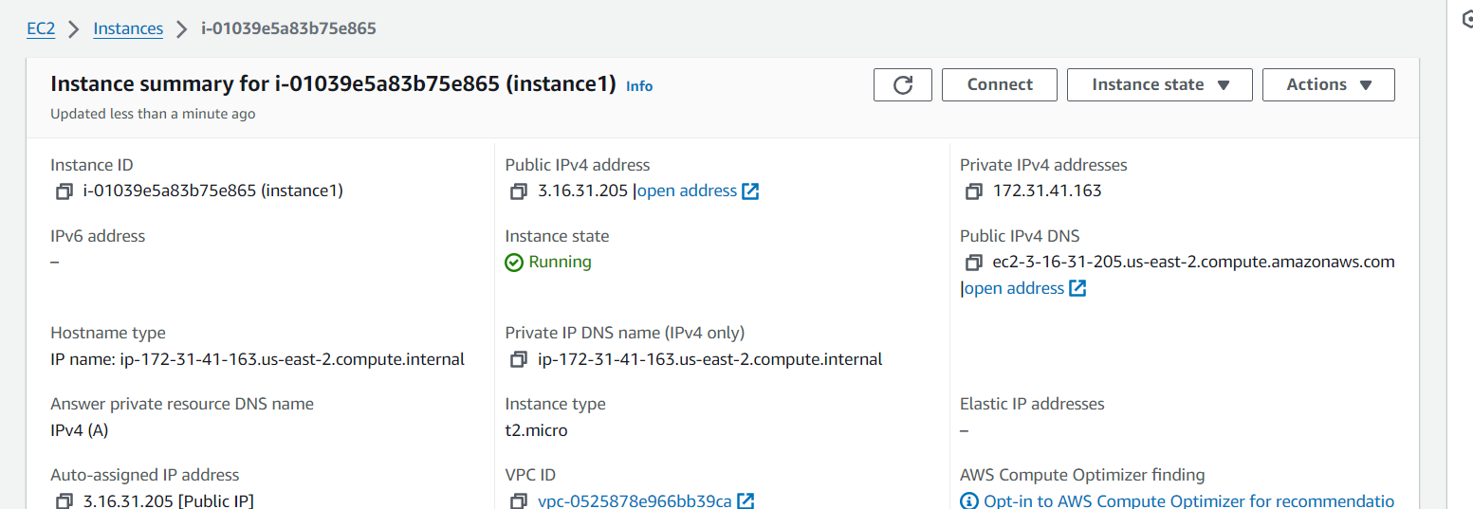

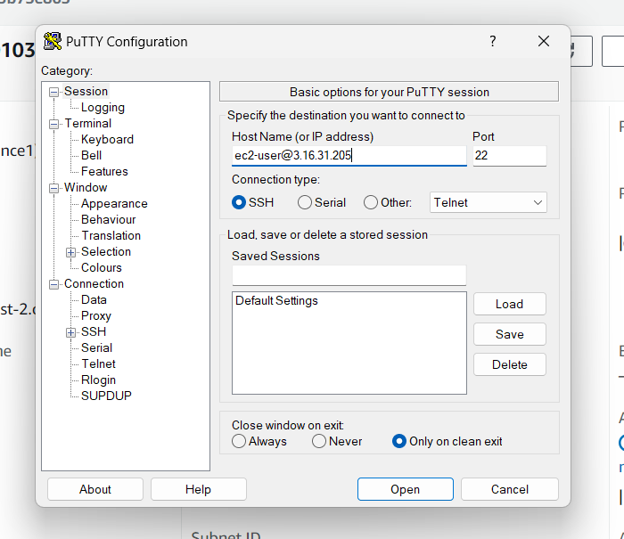

Then open SSH in that open auth in that open

And add your putty link to the credentials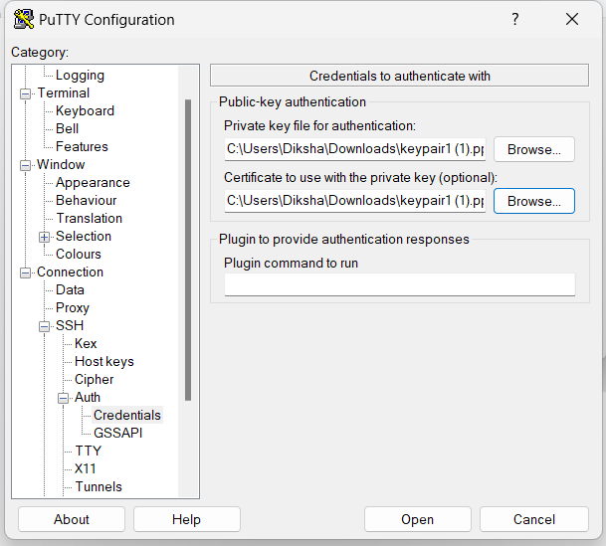

Move to the root user sudo -i

Yum update -y

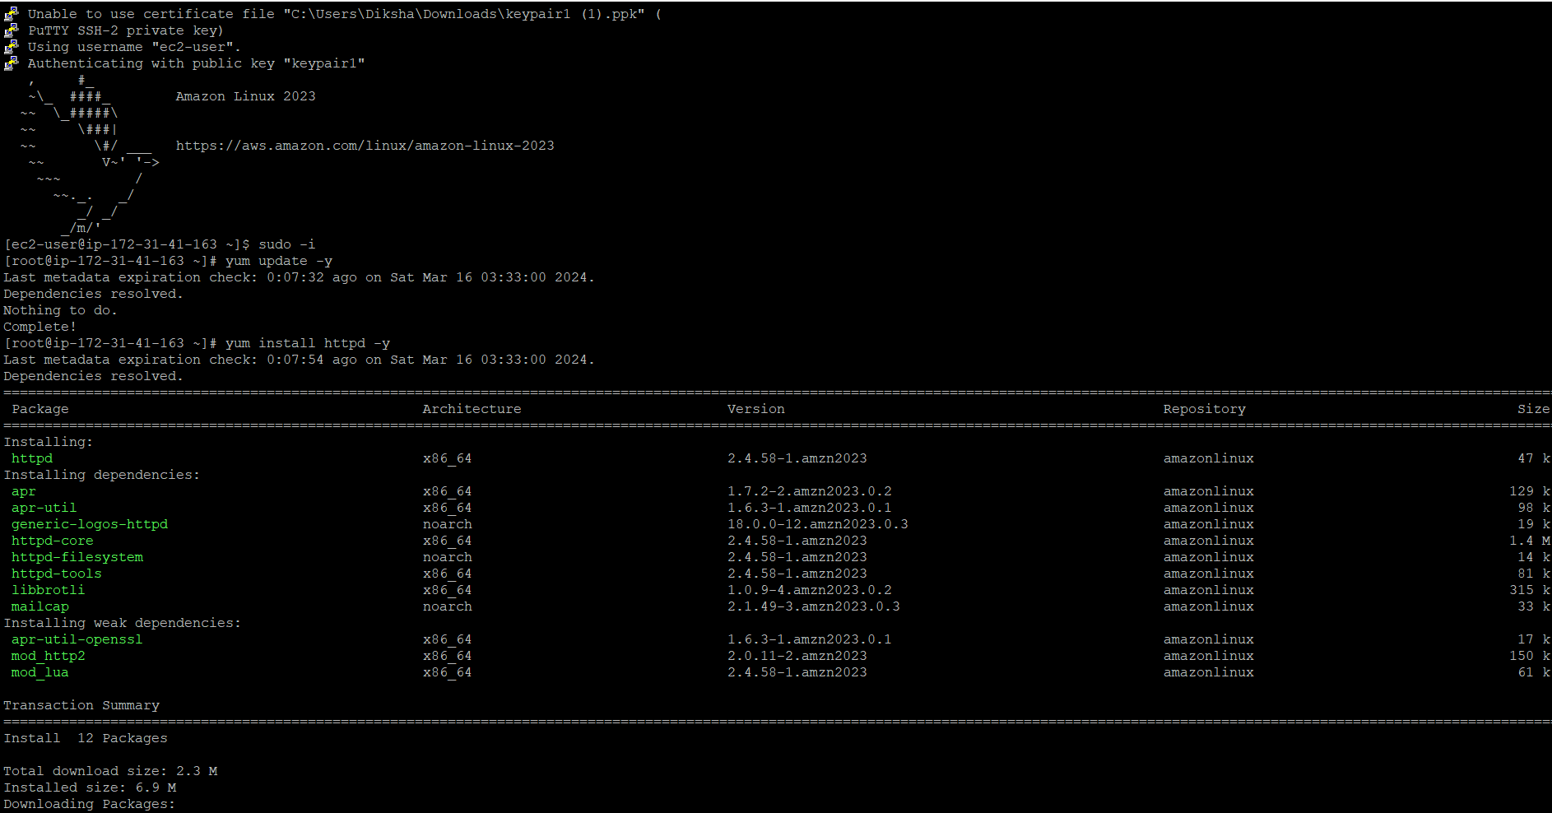

Yum install httpd -y

System start httpd

System status httpd

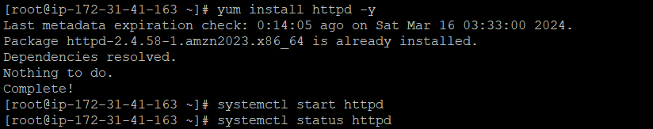

Cd /var/www/html

Vi index.html

Cat index.html

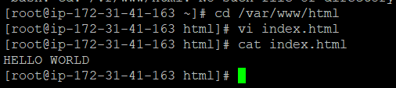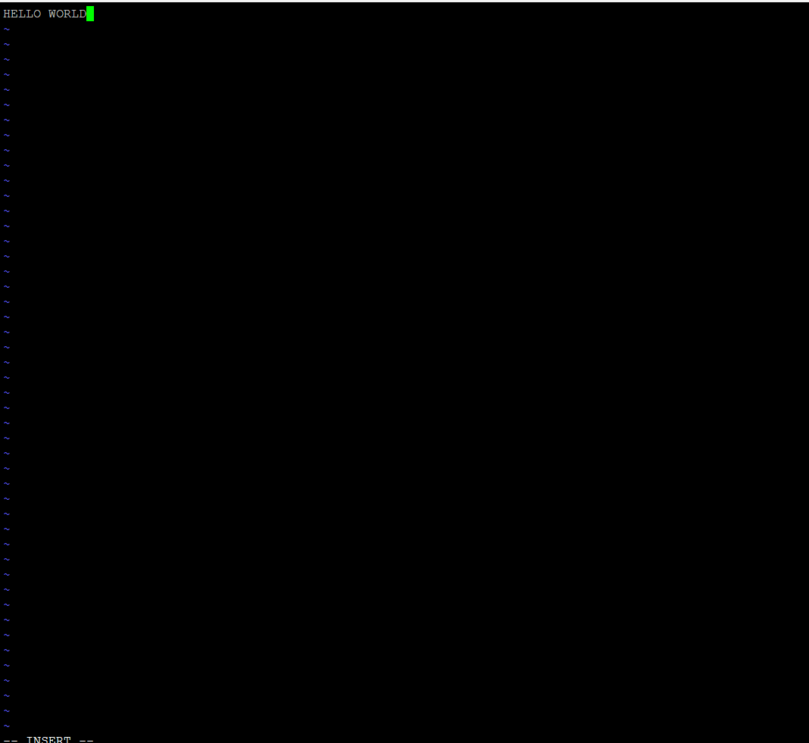

Copy ipv4 link

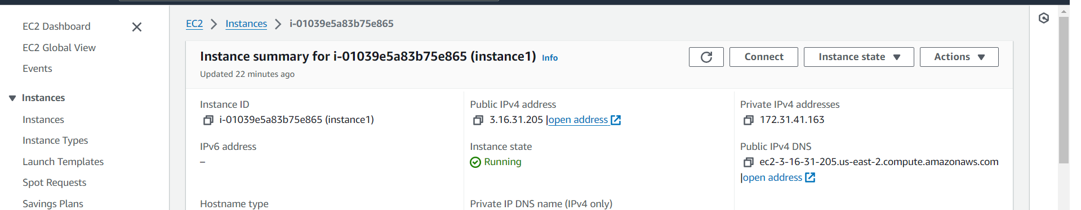

Here is the output

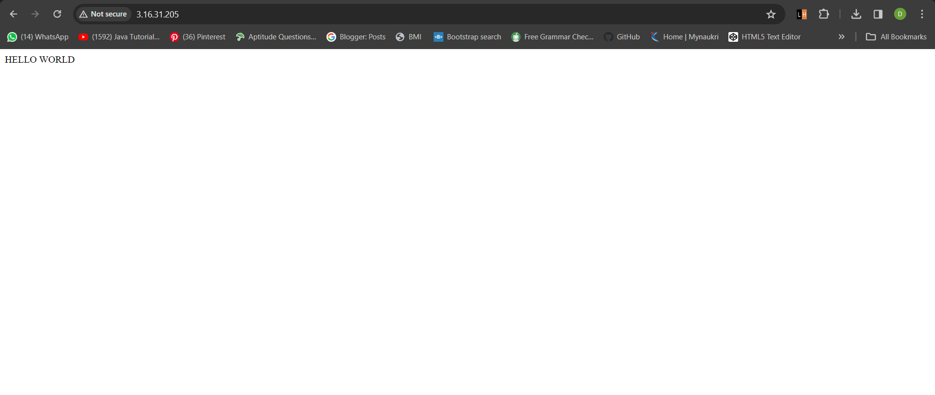

**S3 BUCKET**

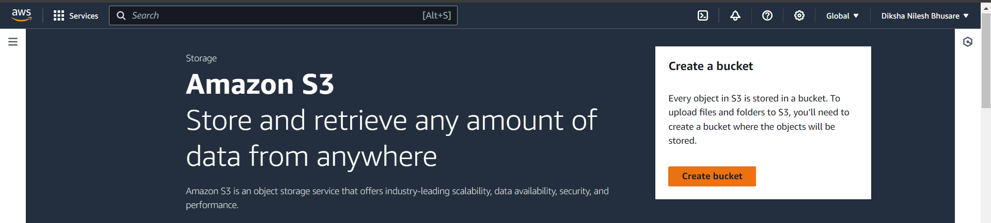

**Select aws region**

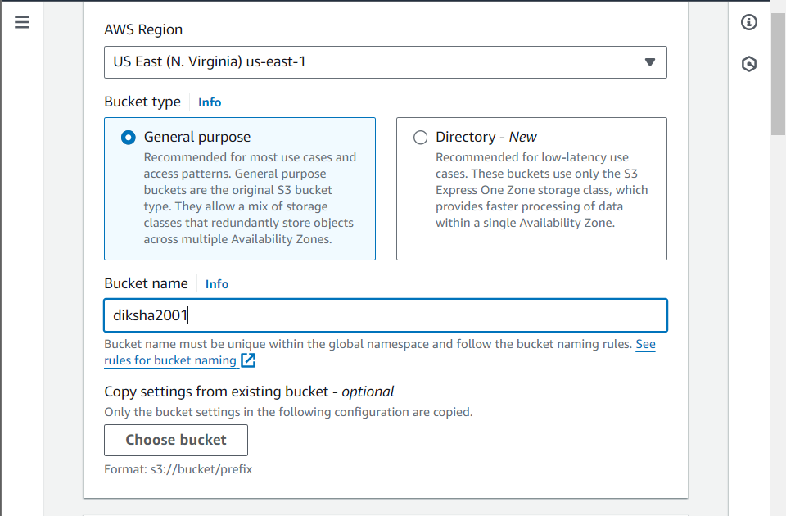

**Enable acls**

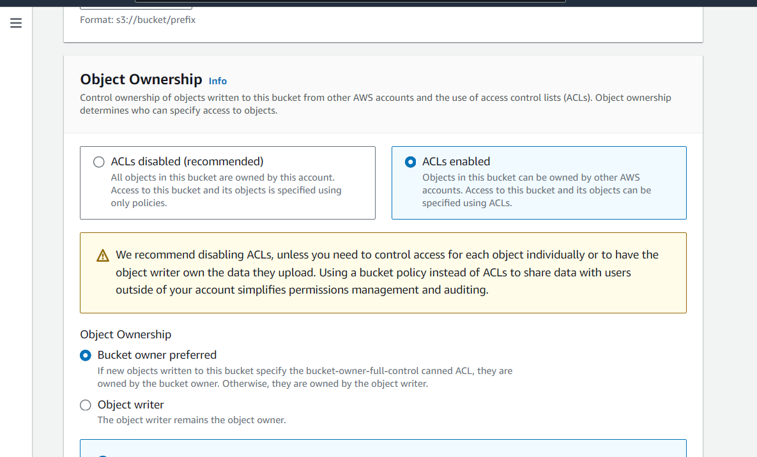

**Uncheck the block and give it to the public access**

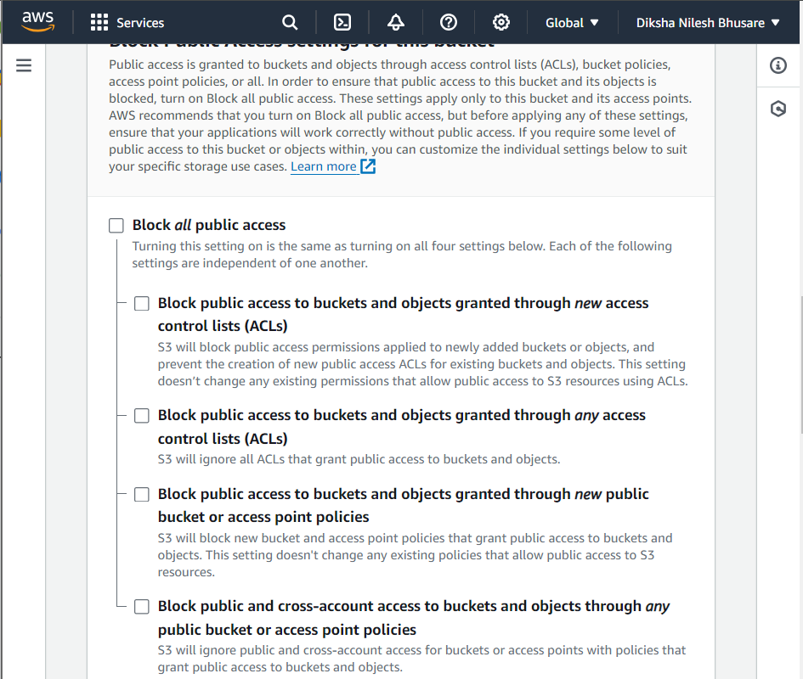

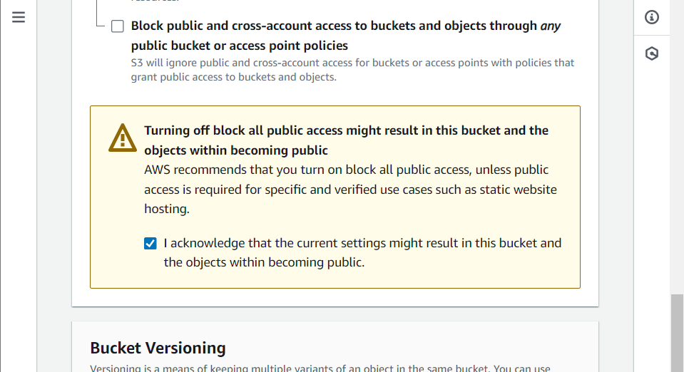

**Bucket key disabled**

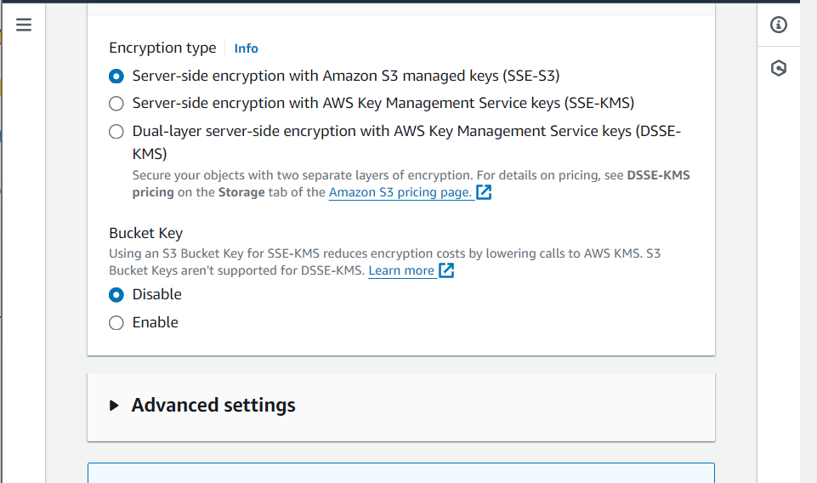

**We crated bucket successfully**

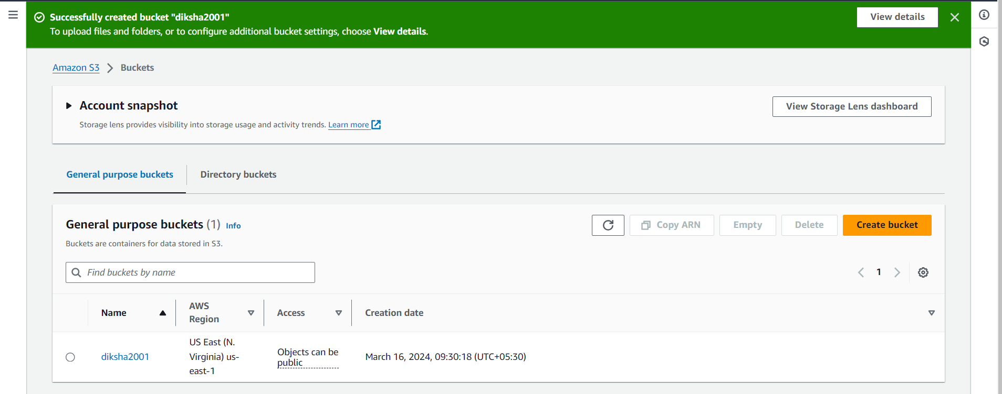

**Here, we are uploading the images**

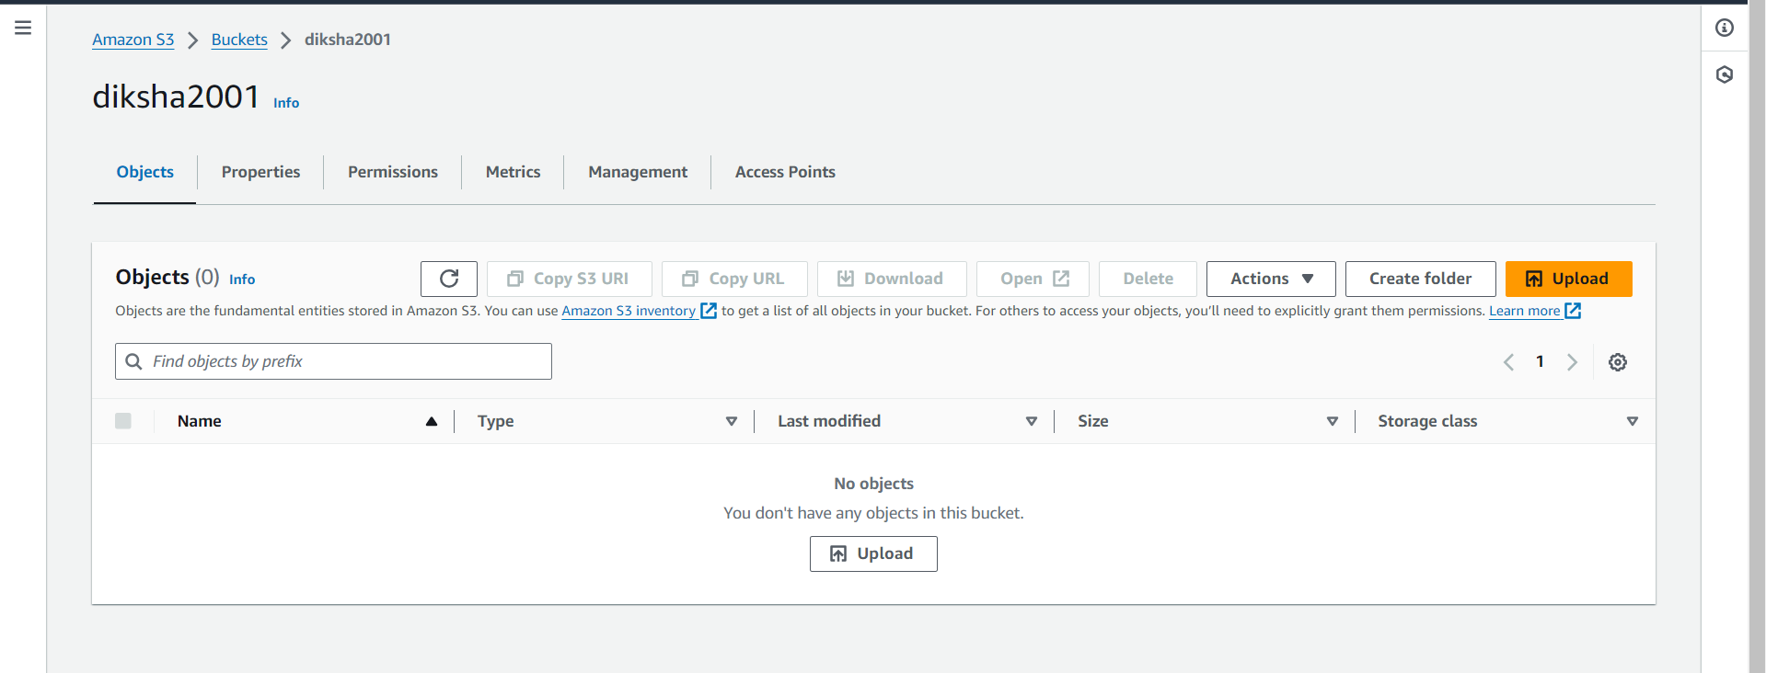

**Upload files and folders here**

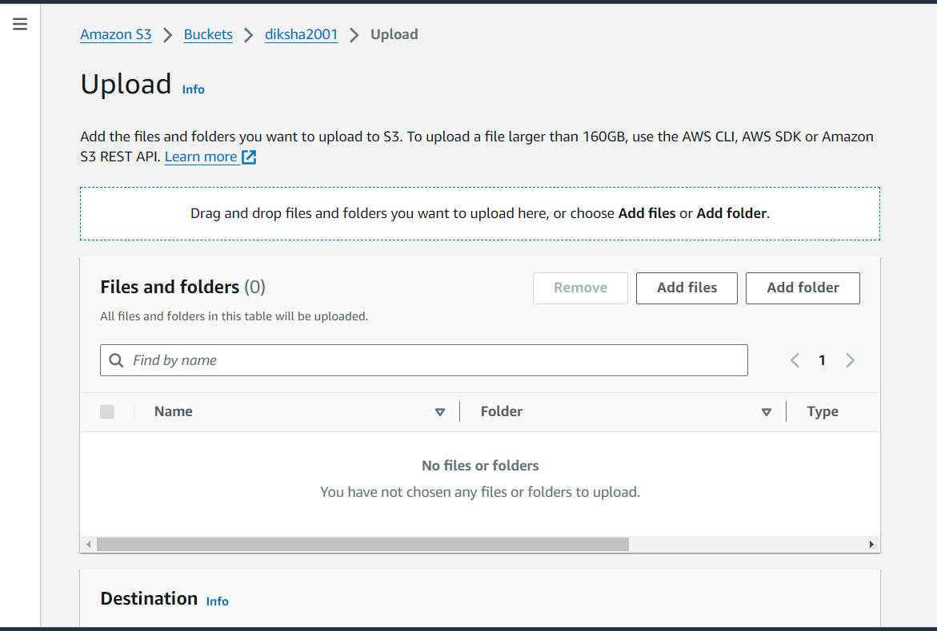

**Click on image**

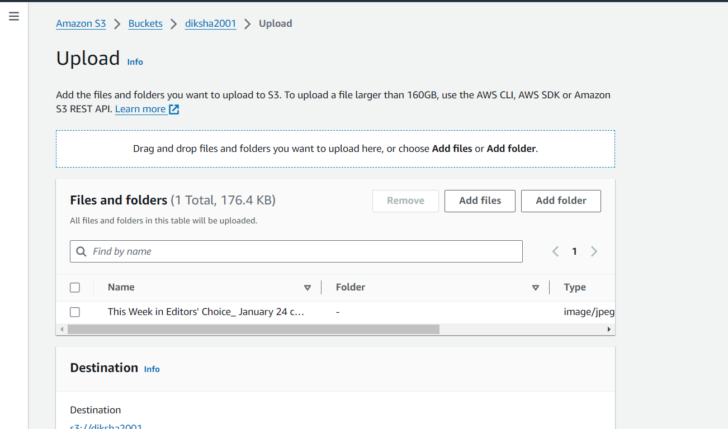

**image is uploading**

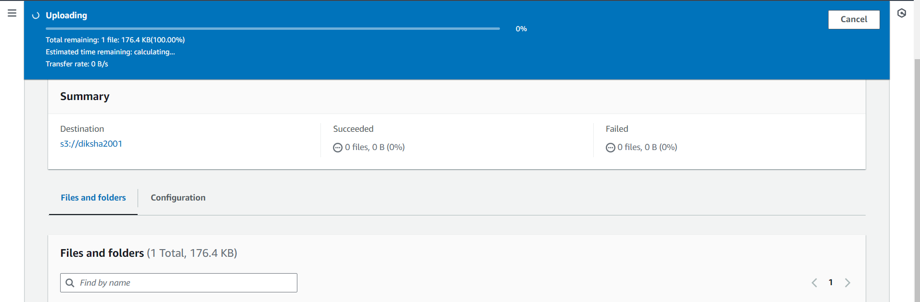

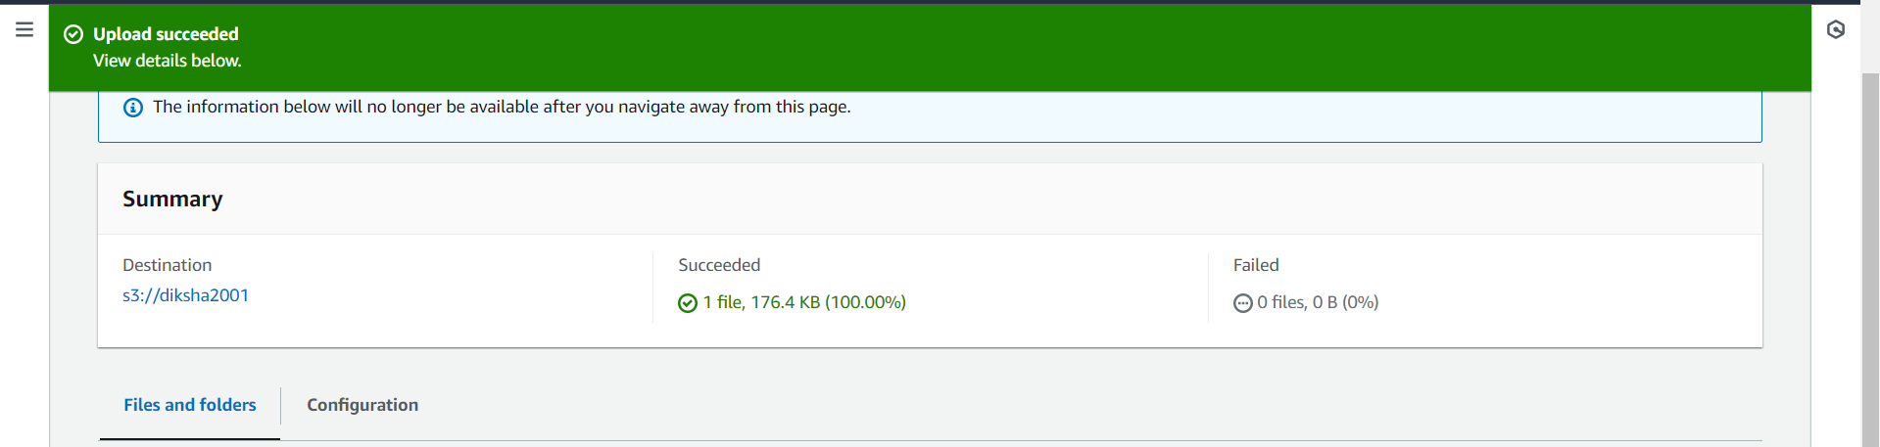

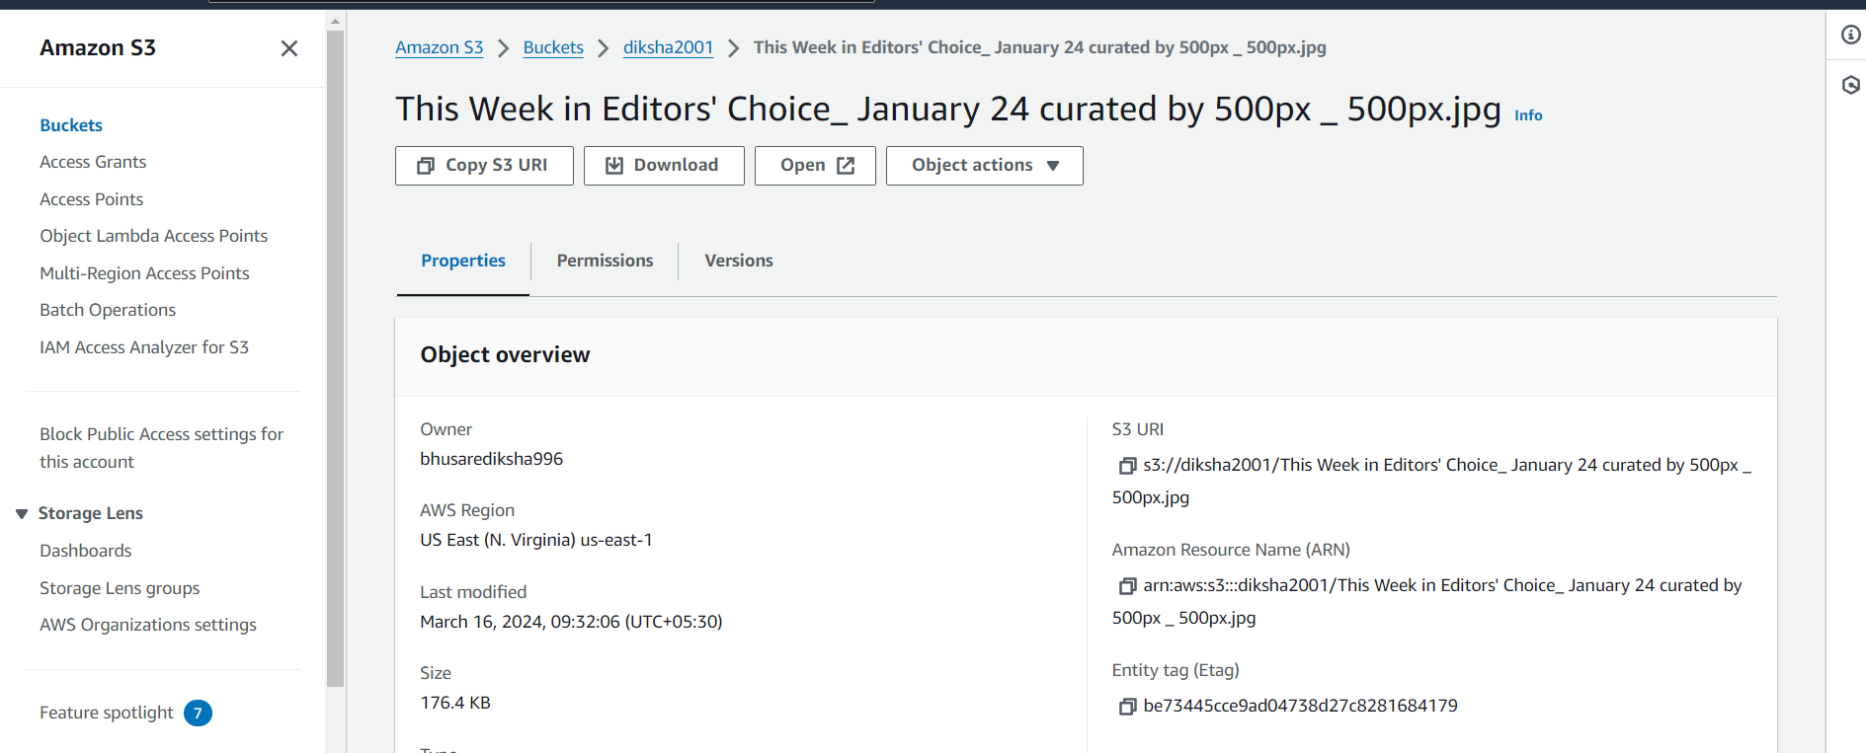

**We need edit permission here**

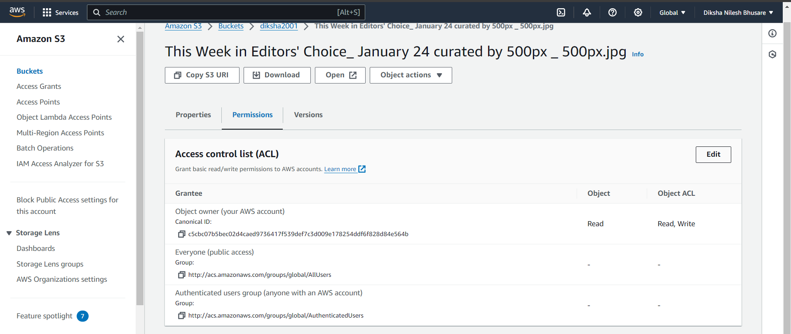

**Edited access control list**

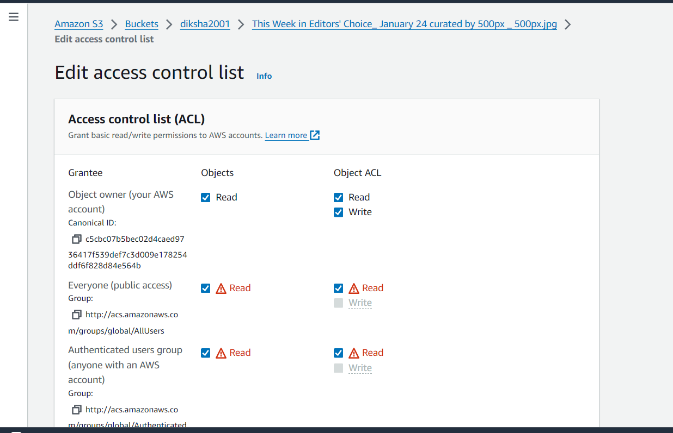

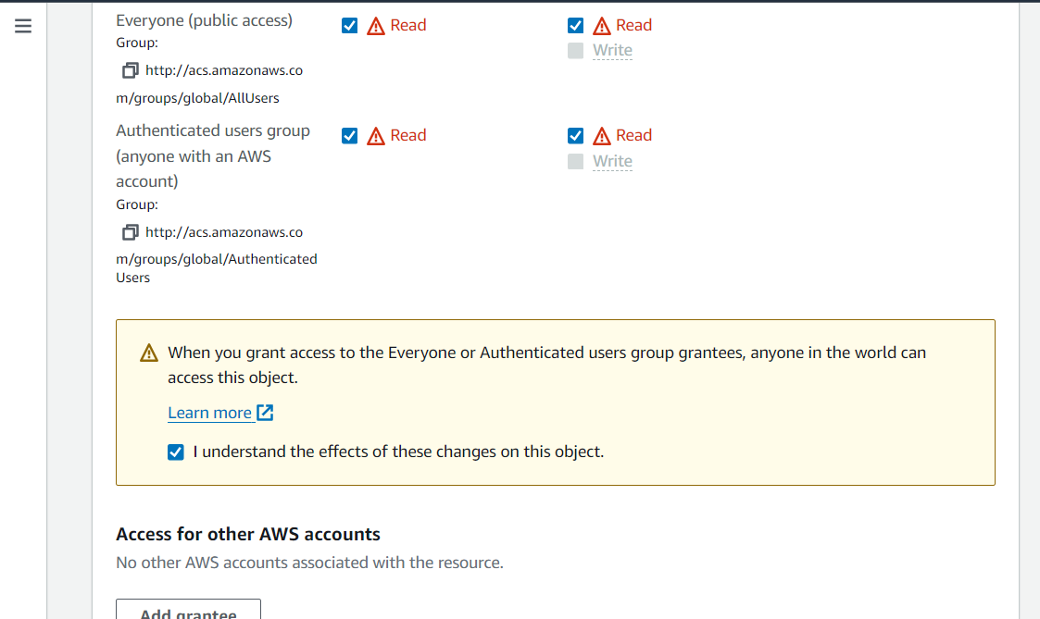

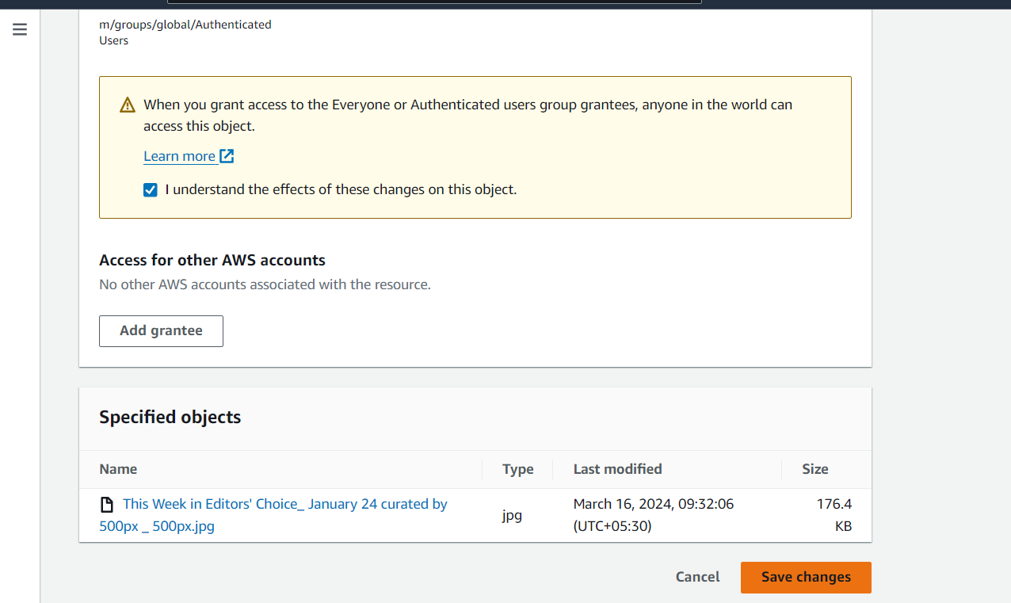

**image is generated here using an object link**

